Turn ‘Off’ Supra Showing and Feedback Notifications

- Go to www.supraekey.com
- Select Agents – Log on to SupraWEB.

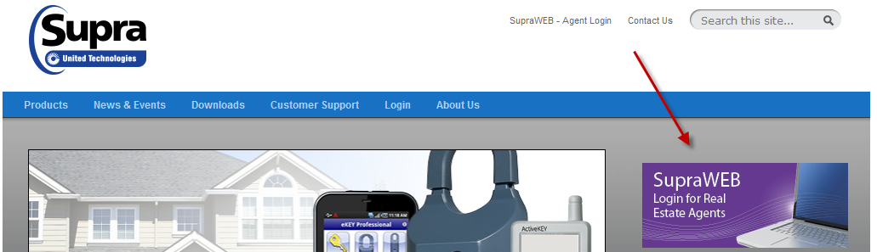

- Enter your user ID and password and select Login.

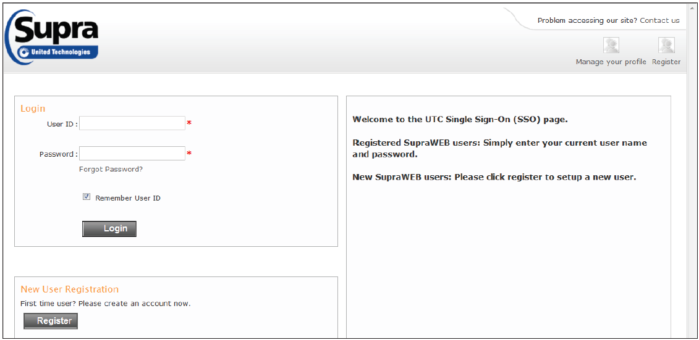

Note: If you have not created a SupraWEB account, click Register; create a USER ID and Password. The first time you login with your user ID and password, you will need to enter your key serial number, PIN, and Board/ Association (Great Plains MLS - Omaha). If you have the SupraKEY on your phone your key serial # is located at the top of the app. If you have the grey/blue ActiveKEY, your key serial # is on the back of the key under the barcode. If you need assistance with this process you can contact Supra at 402-619-5566.

Shut off Email Notifications

- From the SupraWEB homepage select SETTINGS.

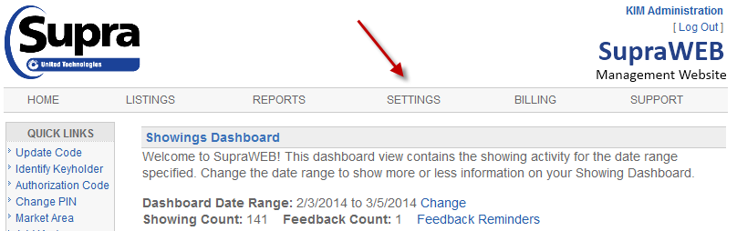

- Select General Email.

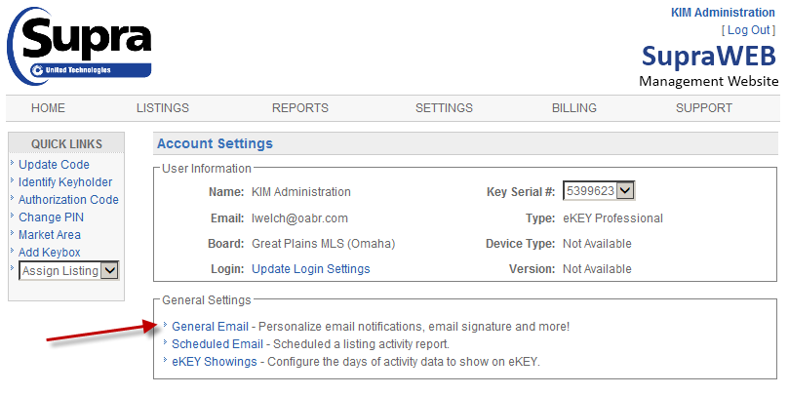

- Uncheck the five boxes, as shown in photo below and click, SAVE.

